Guidance for Library Staff: Libby Card Verification
Overview
On August ??, 2026, Libby will require a necessary card refresh and PIN. This will impact your patrons who use Libby. Library patrons may experience a card verification prompt when they attempt to borrow an item or place a hold in Libby. These patrons will have to reenter their card number and their PIN.
What does verification look like in Libby?
This is what it looks like when a patron is prompted to verify their card at the point of checkout:
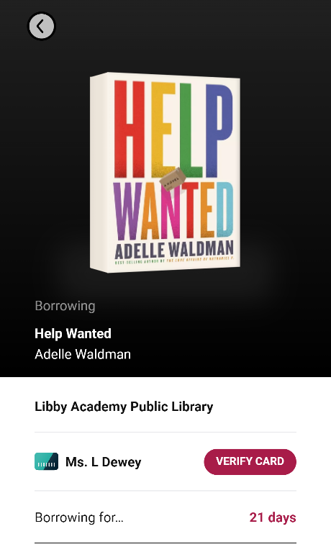
When they look at their list of cards (tap the hamburger menu/horizontal lines/center menu to see the list), patrons who need to verify a card or cards will also see the following prompt:

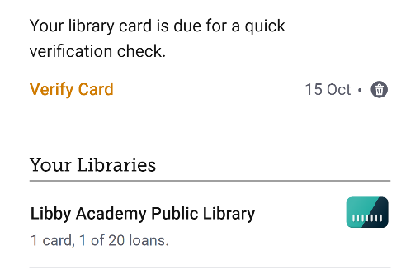

When they tap the “verify cards” button on either screen, they will be presented with boxes to fill in their card number and/or PIN.

How to find a Patron’s PIN in MSC:

How to find a Patron’s User Key in MSC:

How to help?
Most of the time, patrons will just need to type in their card number and PIN. Issues can arise when patrons aren’t sure of their PIN or card number.
Sometimes, if they mistype their card number or PIN, patrons get caught in a “verification loop” where they are repeatedly asked to reenter their card number and PIN. To resolve this issue, remove the library card from Libby and re-add it. Patrons’ checkouts and holds are tied to their card number, not their device, so removing the card does not cancel their checkouts or their place in line: their items will reappear on their Libby shelf when they re-add the card.
Do not uninstall the app, as this can permanently delete reading history and tags on certain models of phone and tablet.
Further Considerations
If you are having trouble helping a patron, you or they can reach out directly to OverDrive’s Technical Support Team through the app or by filling out a support form online through OverDrive Marketplace (Marketplace HomeSupportTechnical Support). This form is how we assist with patron-level inquiries. All inquiries are addressed within a 24-hour timeline.
Submit an MSL Ticket. Please note- we also use Overdrive’s Technical Support Team, but we also have some dedicated individuals to help us with this transition.

